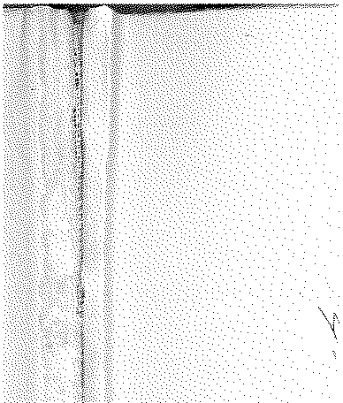

# Annual Vol ume of

TH E LAW S



# of Western N igeria

1962

## containin g

the Laws of Western Nigeria

and subsidiary legisla tion made thereunder



LOS ANGELES COUNTY

LAW LIBRARY

***B*** *265*

**W.N.L.N. 107 of 1962**

*The Local Government Law (Cap. 68)*

THE CONTROL OF DRUMMING ADOPTIVE BYE-LAWS IKOS! DISTRICT COUNCIL

DATE OF COMMENCEMENT: 29TH MARCH, 1962

#### Notice is hereby given that in exercise of the powers conferred upon the

!kosi District Council by sections 83 (2) and 276 of the Local Government Law, Cap. 68, the Jkosi District Council in accordance withsections 83 (3)(a) **of the Local Government Law, Cap. 68, has resolved at its meeting held**

on the 13th day of J nuary, 1962, that the Third Schedule to the lkosi

#### District Council Control of Drumming Adoptive Byelaws published as

W.R.L.N. 361 of 1959 be amended as follows:-

**Amendm ent** to W.R.L.N. 361 of 1959.

***Description of Drum***

THIRD

***Fees***

SCHEDULE

*Period*

#### lBetween the hours of 6 a.m. to 6 p.m.

|  |  |  |
| --- | --- | --- |
| Iya-Ilu or Dundun | *s*  7 | *d*  6 |
| **Kete or Agasa** | 7 | 6 |
| Bata Koto | 7 | 6 |
| Apala/Sakara | 7 | 6 |
| Juju ... | 7 | 6 |

and 6.p.m. to 6 a.m.

J



I badan, 26th March, 1962.

J. M. BECKLEY'

### Permanent Secretary, i.Vlinistry of Local Government